HARDWARE AND COMPONENTS BASICS

ASSIGNMENT DAY1
TASK1. Draw a labeled diagram of an ATX motherboard and mark at least 8 different slots and ports (such as RAM slots, PCIe slots, SATA ports, USB headers, CPU socket, power connector, etc.).
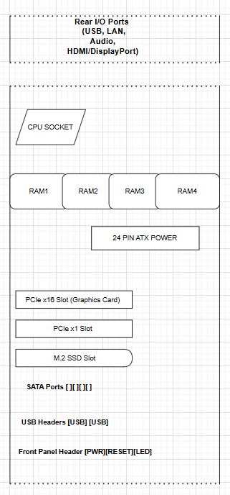
SLOTS AND PORTS:-
- CPU Socket
- RAM Slots (DIMM Slots)
- PCIe x16 Slot
- PCIe x1 Slot
- SATA Ports
- M.2 SSD Slot
- 24-Pin ATX Power Connector
- USB Headers
- Front Panel Header
- Rear I/O Ports
TASK2. Research and list 3 popular CPU socket types (for example: LGA1151, AM4, LGA1200) and name one compatible CPU model for each.
CPU Socket Type | Manufacturer | Compatible CPU Example
LGA1151 | Intel | Intel Core i7-9700K
AM4 | AMD | AMD Ryzen 5 5600X
LGA1200 | Intel | Intel Core i5-10400F

TASK3. Explain in your own words the primary functions of the CPU and the chipset on a motherboard, and describe how they work together when you open a music app like Spotify.
CPU (Central Processing Unit)
The CPU is the main processing unit of a computer. It executes instructions, performs calculations, and manages tasks requested by software and users. The CPU is often called the "brain" of the computer because it controls most operations.
Chipset
The chipset is a group of electronic components on the motherboard that manages communication between the CPU, RAM, storage devices, USB ports, and other hardware. It acts as a traffic controller, ensuring data moves correctly between components.
How They Work Together When Opening Spotify
When I open Spotify, the CPU processes the command to launch the application and loads the necessary program instructions. The chipset helps transfer data between the SSD, RAM, audio hardware, and CPU. The CPU executes the software while the chipset manages communication with storage, speakers, and network devices, allowing Spotify to load and play music smoothly.

TASK4. Find a clear photo of a real motherboard (from the internet or your own device), and identify at least 5 different ports or slots by circling them and labeling each one.

